GWI CIR Report, January 2022
Grace O’Malley, CIR

GWI has developed an online offering to ensure we can continue to learn, access and communicate, in order to maintain our relationship, during these unprecedented times.
It is most disappointing that all our planned face to face meetings could not go ahead again this year. Although the safety and well-being of everyone requires us to physically separate from one another, the GWI Board, Committees, and Office remain committed to our global membership community of graduate women. Through this unprecedented period, GWI will continue doing what it knows best: raising the voice of graduate women around the world and working for the preservation and improvement of women's and girls’ fundamental right to education.
This year has been a very exceptional year for GWI, with little opportunity for face-to-face meetings. GWI had intended to represent a large delegation at the 64th session on the Commission on the Status of Women in New York in March to mark the twenty-fifth anniversary of the Fourth World Conference on Women and adoption of the Beijing Declaration and Platform for Action (1995), as well the global drive to achieve the United Nations Sustainable Development Goals of the 2030 Agenda for Sustainable Development. But alas the worldwide pandemic of COVID-19 intervened.

However, GWI rose to the challenge and maintained regular contact with our members. We have ‘spoken’ to more members during the first year of this 2020-2022 triennium then in the past, thanks to the several national, regional, or global Zoom meetings and webinars GWI and her regions organised this year.

GWI knows that in crises such as we are experiencing now, pre-existing social inequalities and injustice are often deepened. GWI is concerned that girls will be impacted the most by school closings in many countries, as they least likely to return to school and in many areas most vulnerable to drop out. For this reason, GWI is resolutely focused on continuing to pursue its mission as routinely as possible in support of our almost 15,000 members across the world and to remain engaged and energised through this evolving global challenge.
Some of the highlights of the past year are below:

On 24 January 2021, GWI joined with the world in observing International Day of Education. On this third International Day of Education, our membership worldwide celebrated education and the positive role education plays building peaceful societies. GWI voiced deep concerns about the disturbing inequalities in education exacerbated globally by the COVID 19 pandemic, especially the digital divide affecting women and girls. GWI underscores the need for collaborative efforts to raise awareness about the crucial digital learning crisis continuing as pandemic fallout.

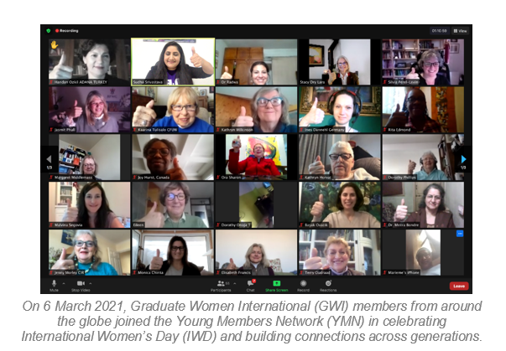

Young Members Network in celebrate International Women’s Day
On 8 March 2021, Graduate Women International (GWI) joined the international community in celebrating International Women’s Day (IWD), a day for world citizens to shine a spotlight on gender equity issues. This years’ theme “Women in leadership: achieving an equal future in a COVID-19 world” marked the tremendous efforts by women and girls around the world in shaping a more equal future and recovery from the COVID-19 pandemic.

Statement by GWI on Turkey’s withdrawal from the Istanbul Convention.
GWI’s international network of graduate women, jointly express concern for all Turkish women, and stand in special solidarity with our Turkish sisters of Türk Universiteli Kadinlar Dernegi, (Turkish Association of University Women). GWI and all her members urge the Government of the Republic of Turkey to reconsider its withdrawal from the Istanbul Convention, which builds on the standards enshrined in the Convention on the Elimination of All Forms of Discrimination against Women as well as its general recommendations. We urge the continued protection of human right of all women and girls to live free from violence.

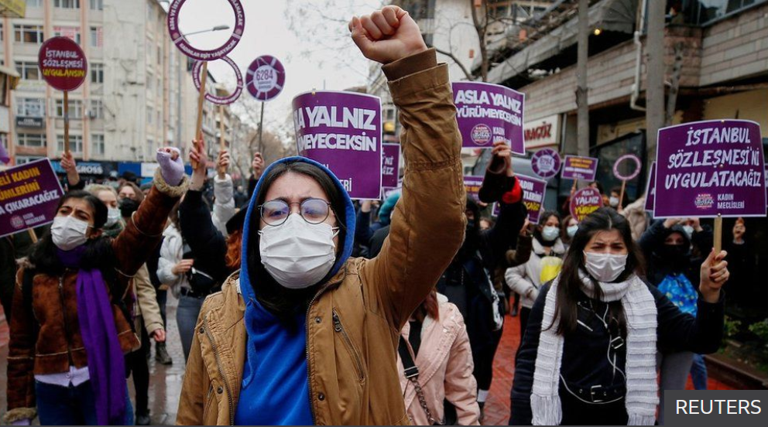
Women rally in Ankara, Turkey against Turkey's withdrawal from the Istanbul Convention

UWE online Meet and Greet, 15 May
GWI regional group, UWE, announced its online Meet and Greet “Celebrating European Women”, hosted by the Irish Federation of University Women (IrFUW) on Saturday, 15 May 2021. After an introduction to Women in European Film, a virtual tour to the Oratory of the Sacred Heart in Dun Laoghaire, as well as the sharing of traditional recipes and musical performances. The event was a great success and feedback has been very positive - well done IrFUW! This event was open to all members of the UWE and their friends.

GWI Menstrual Hygiene Day Advocacy Campaign:
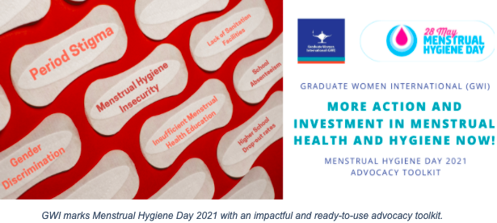
Menstrual Hygiene Day (MHDay), observed annually on 28 May, is a reminder that women and girls across the world continue to face a variety of unnecessary challenges due to their menstruation. This year, GWI marked its fourth observance of MH Day with the release of an informative, impactful and ready-to-use advocacy resources toolkit, including the GWI 2021 MHDay infographic and prepared social media posts. Affiliates and friends were encouraged to widely distribute the toolkit to local, national and international channels.
The IFUWA and EAUW joint webinar, India and Egypt partnership, on “Confronting and Combating Harassment” took place virtually on May 29th 2021
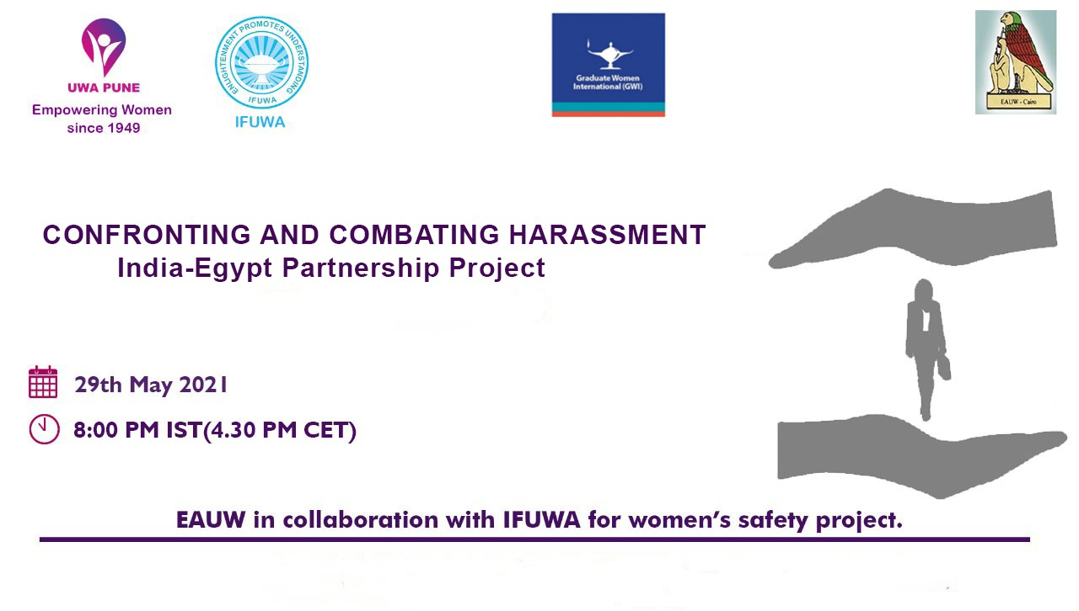
This webinar, Confronting and Combating Harassment, touched upon varied legal, social, and psychological aspects of this global issue.
On June 30th, GWI joined the international community in marking International Day against Child Labour by holding an exclusive webinar on the effects of NEET (Not in Education, Employment, or Training) in changing times. The effects of NEET in today’s changing world was examined from an intergenerational perspective.
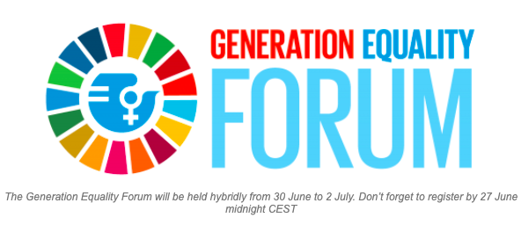

GWI was honoured to welcome two International Labour Organisation (ILO) guest speakers, Mr. Shane Niall O’Higgins and Ms. Adrienne Cruz, ILO Senior GenderSpecialist. O’Higgins is Senior Economist in the ILO's Employment Analysis Unit and Professor of Economics at the University of Salerno. Previously, Lead Researcher in the ILO's Youth Employment Programme; he is one of the main authors of the ILO's biennial Global Employment Trends for Youth. Cruz is co-author of the publication Gender-Based Violence in the World of Work. Among other duties, Cruz coordinates the ILO Action Plan for Gender Equality, and the ILO Global Gender Network. Both shared their expertise and answered questions from GWI members and guests.
GWI at the UNHRC
After more than a year dominated by the COVID-19 pandemic, efforts to shape global development and the implementation of the United Nations (UN) 2030 Global Agenda on Sustainable Development must not be in vain. While this 47th session was held remotely, the events were no less captivating. The GWI Update Newsletter highlights some of the events and final resolutions which support GWI’s advocacy work to advance the status of women and girls through the safe access to quality, lifelong education, and learning.
High-level Panel Discussion on the Multi sectoral Prevention of and Response to FGM
The United Nations High Commissioner for Human Rights, Michelle Bachelet, introduced this panel by recording that FGM affects women and girls in around 90 countries according to a recent study. The pandemic’s backlash on secondary schools has deepened the scourge of FGM. Furthermore, she highlighted how “girls and women must have access to information, education, health care and social justice.”
She highlighted how a multi stakeholder approach is necessary to combat it, within countries but also internationally. To eradicate FGM by 2030, Burkina Faso’s president appealed all the actors to “comply with the requirements of resolution 44/16 by mobilising financial resources and allocating them to the prevention and elimination of female genital mutilation”. The panelists then reaffirmed the need to accelerate efforts to combat this severe assault on women’s and girls’ bodies, and that there was progress, albeit uneven.
IAUW's successful scholarships
The Jerusalem Branch of IAUW has awarded over 600 scholarships in the last 50 years to doctoral women students at the Hebrew University of Jerusalem. This year, they awarded 9 scholarships of 6,000 NIS each to women doctoral students, and heard very interesting resumes about their research.
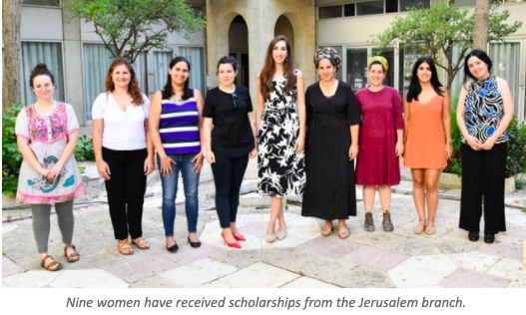
Three years ago, when the Tel Aviv-Central Branch of IAUW was reorganized, they also started a scholarship fund. The Branch has adopted a number of institutions for young girls-at-risk. Members of the Branch mentor and help these young women in various ways. This year they awarded 19 scholarships of 6,000 NIS each.
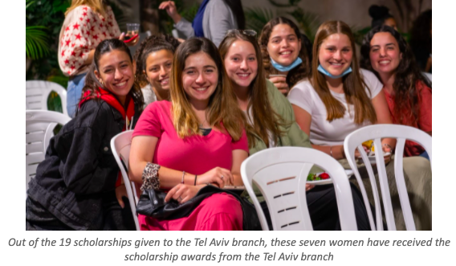
August 2021 An Organizational Development (OD) process to accelerate GWI’s work for women’s and girl’s education was presented at the GWI Town Hall Meeting on 23 June 2021. GWI’s Immediate Past President, Geeta Desai, agreed to conduct this process without charge to GWI. To initiate the work, we requested that each NFA select one member from within its organization to serve on the Organizational Development Steering Committee and Grace O’Malley has agreed to represent IrFUW on the OD Committee, which began its process in October 2021.

September: GWI concludes its “Connecting Across Generations” series
The “International Day of Peace: Celebrations Across Generations” webinar took place in September, concluding GWI’s four-part “Connecting Across Generations” webinar series which was organised by GWI’s own Young Member Network
This final webinar focused on the concept of peace and the significant role education plays in peace processes, in honor of the International Day of Peace on Tuesday, 21 September. The webinar concluded with the lighting of the GWI lamp, after which attendees were given the opportunity to share a brief statement about what peace means to them. GWI would like to thank all those who contributed to this final discussion as well as all those who were in attendance. “The GWI young member network leadership has done exceptional work producing the Connecting Across Generations webinar series. This group of intelligent and insightful women is GWI’s future as the leading young network of graduate women who aim for equal opportunity for the safe education for women and girls of all ages”, says Stacy Dry Lara, GWI Executive Director.
GWI releases 2021 IDOG: “Digital generation. Our generation.” Toolkit
In 2011, the United Nations (UN) General Assembly passed a resolution adopting 11 October as the IDOG. This day, synonymously known as International Day of the Girl Child, Day of Girls, and International Day of Girls, it is celebrated annually and serves to promote the recognition of girls’ rights. It is a reminder to the international community of the unique challenges girls face around the world and particularly highlights issues concerning gender inequality. This year, GWI aligned with the UN International Children’s Emergency Fund (UNICEF) to celebrate girls’ abilities to act for their own fate with the theme “Digital generation. Our generation”. GWI marks this day with the release of a ready-to-use advocacy toolkit to help achieve positive outcomes for girls’ empowerment. This toolkit contains impactful facts and information, advocacy ideas, an exclusive GWI IDOG proud member banner, and a comprehensive social media package to reach a wide and diverse audience and promote GWI’s work and values.

November: GWI 16 Days of Activism Against GBV toolkit
In honor of the 16 Days of Activism Against GBV, GWI crafted and released a 2021 toolkit to help inspire and promote activism around the globe. GWI strongly encourages its members to read the toolkit, including GWI’s impactful social media posts and infographic to help to raise awareness of the 16 Days. On top of social media, the toolkit recommends other ways in which individuals can stay active, including reading relevant literature, watching thought-provoking media, and perhaps designing a strategic advocacy plan that is all your own.
December: GWI holds women in information technology webinar
Hosted by the Pakistan Federation of University Women (PFUW) the GWI regional group, University Women Asia (UWAsia} held on 18 December 2021 a webinar titled, “Research and use of advanced information technology can bring sustained improvement in the socio – economic status of global women'' and “Traumatic impacts of long years of war on Afghan Women”.
Dr. Rashida Zohra, Dean Jinnah University for Women, was the first guest speaker who went back into history of evolution of various scientific inventions by women. She stressed on the fact that women with STEM education proved their credibility by coming up with inventions like torpedoes and improved technologies in the Second World War. She stressed that women have made their names in Pakistan by making use of advanced information technology in the area of software development and they have sizeable share in IT related products exports of the country.

UNESCO to Increase investment in education in the aftermath of COVID-19
At the height of the pandemic, 1.6 billion children and adolescents were deprived of instruction in the classroom. Among them, 500 million students, mainly in the Global South, had no access to distance learning. (UNESCO) quickly rallied by bringing together States, international organizations and businesses within a Global Coalition for Education, which made it possible to ensure educational continuity in 112 countries. Despite this unprecedented mobilization, the situation remains worrying. According to UNESCO’s latest count, schools are still totally or partially closed in 65 countries, affecting 750 million students. In those countries where schools are reopening, there is concern that some children are not finding their way back to the classroom. This is particularly the case for girls, whose schooling was already precarious in a number of low-income countries. UNESCO estimates that 11 million girls worldwide are at risk of staying out of school after the pandemic. These risks are observed against a global backdrop of under-investment in education.

ENDS

